Chapter 0

CPS 480 - AI - Chapter 0
What is the difference between AI and auto-system or programming?
Learning

What are two essential factors for AI to take off?
Hardware and Data

Why do we need AI?
Uncertainty

Difference between AI and machine learning?

AI System
- Agent == decision maker (robot)
- Environment == world it operates in
- Percept == info the agent receives / input (keybaord, camera, etc.)
- Effectors == Parts that act / output (wheel, speaker, legs, etc.)
- Action == What the agent does

- Is Air conditioning an AI system?
  - Not the old ones, but the new ones are. The new ones sense the environment (input) and use that knowledge to figure out what temperate it should output where
- Is calculator AI?
  - No, but if you get a high tech one that uses voice recognition it is because the input is voice and output is the calculation

AI Model
- Knowledge == model == Parameters + formula
  - Parameters == set of numbers
  - Formula == math or logical relationship about parameters

- Say you want to predict a house price, price depends on a lot (size, location, etc.)
  - Manually you could do this with graphs and going through a bunch of recently sold houses to see a pattern
  - If found to be linear
    - price z = f(x, y) = ax + by + c
    - a, b, c == parameters
  - If found to be quadratic
    - price z = f(z, y) = ax^2 + by^2 + cx + dy + e + xy + f
    - a, b, c, d, e, f == parameters

Chapter 1

CPS 480 - AI - Chapter 1

Search Definition
- AI Search == find a path from starting point to a destination
  - Focus on the path
  - Path = a sequence of actions
  - Starting point == initial state
  - Destination == goal state
    - Can be known before search start
  - If you had a map with a bunch of locations and distance markers between them and had to reach a location. Then the initial state would be the location you start in, the goal state would be the location you want to reach, each location would be a separate state, and the path would be each location you travel to on the way to your goal.
    - 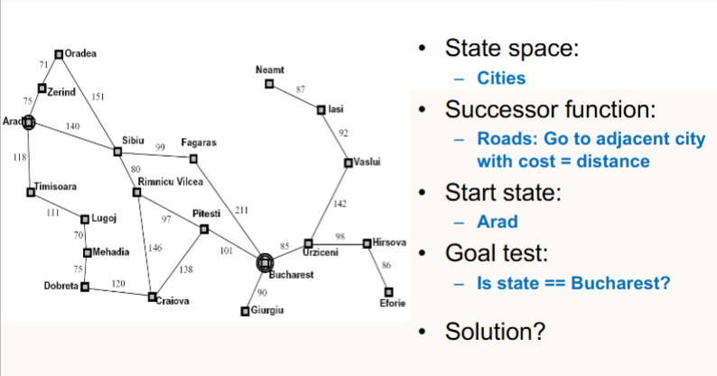
  - AI search gives me the instructions to take to get a solution.
  - From a CS or Engineering perspective, what's a state?
    - a set of variables
  - Success Function == return of all possible actions that transits the agent from current state to next state
    - For the city problem it would be returning the names of all the current city neighbors
  - State Space == the category all the states fit into
    - For the city problem it would be cities because each city is an individual state
  - You can define a state multiple ways per problem
  - Using Sudoku with 5 numbers filled in as an Example:
    - Goal state == completed sudoku board with every number filled in. It is unknown since we don’t know the answer
    - State == all the 81 cell assignments
    - State Space == 10^76
    - Is the goal state unique == no their are multiple
    - Successor function == 76 actions, 1 for each cell changing
  - Rubics Cube Example:
    - Goal State == Completed rubics cube with each side only having 1 color
      - Goal State is unique, their is only 1
    - State == each possible color combination on the cube
    - State Space == < 6^54
    - Successor Function == 27 possible actions,
  - PacMan Example:
    - Goal State == Eat all them balls and get an empty board
      - Is a unique state, we know what it is before hand
    - State == an image of the board storing pacmans location, location of balls, ghost, walls, fruit, or ghost. You could say every frame is a state
      - If image is a state, then:
        - Resolution is 800 x 600
        - 4 possible things per pixel (wall, ghost, fruit, ball)
        - So state space is 800 x 600 x 4
- Traditional search == find or retrieve matching records based on query
  - Google
  - Focus on the destination

Uninformed Search
- Uninformed / Blind search
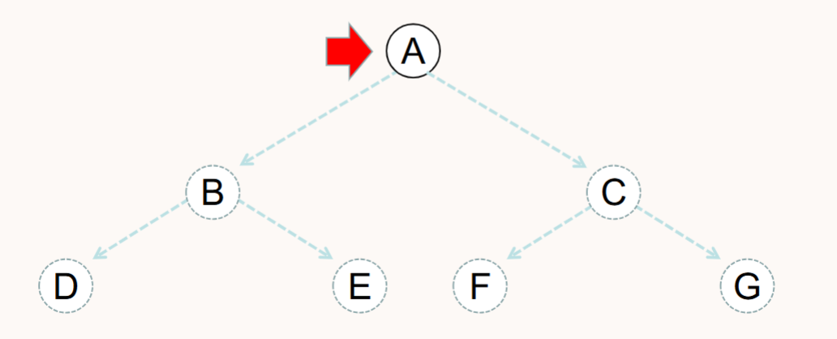
  - Breadth-first == layer by layer, conservative until you found ghost state (Complete)
    - Fringe is a FIFO queue (new successors go at end)
    - We have a goal state and we go down the tree until we reach it, going through different ghost states
      - Ghost states == states we don’t see, its a ghost
    - ABCDEFG
  - Depth-First == go as deep as possible (Non-Complete)
    - Basically follow 1 child all the way down, when you hit a wall you go up 1 parent and check the next child. Repeat until all children explored or found Goal State
    - Fringe is a LIFO (stack, last in first out)
    - ABDECFG
  - Which is better?
    - DFS is bad if their is a lot of loops because it could get stuck in an infinite loop
      - Can solve this with a simple boolean variable that states (visited)
      - Not optimal since it returns first path vs optimal path
      - O(b^{m}) Time
      - O(bm) space
        - Max depth = m
        - b = number of children
    - BFS will traverse the whole state space till it finds the goal state, it then will respond a path of just the parents
      - Seems like the best right? WELL NO!
      - There are multiple copies of ghost states
      - O(b^{d}) Time
      - O(b^{d}) Space
        - d = depth of optimal solution
        - b = number of children
      - Space is the bigger problem over time
    - BFS is optimal and complete, while DFS is non-complete and sub-optimal
    - Space is about Ram while time is about CPU
  - Iterative Deepening Search == Combo of DFS and BFS
    - DFS as a framework
    - BFS as a controller
    - Go down doing DFS with a limit of 1, if you don’t find it make limit 2 and repeat, etc.
      - Can increase limit by different numbers, not just 1
    - So it gets the space of DFS but the time of BFS, which makes it the best of both worlds

Tree Search
- Uniformed = no analysis or follow arbitrary rule
  - DFS, BFS, and IDS
- Informed = agent analysis of the current state then make a decision
  - Greedy and A-star / A*
  - These all share Heuristic Function h(n) which is where you estimate the cost of reaching goal from node
    - Heuristic = guess
    - Pre-defined, we know before we search
- Greedy Search
  - Complete?
    - No → it can get stuck in a loop
  - Optimal?
    - No → it depends on Heuristic accuracy
  - Time?
    - Worst case → O(b^{m})
    - Best Case → O(bd) → only if h(n) is 100% accurate
- A* / A-star

